Question 2

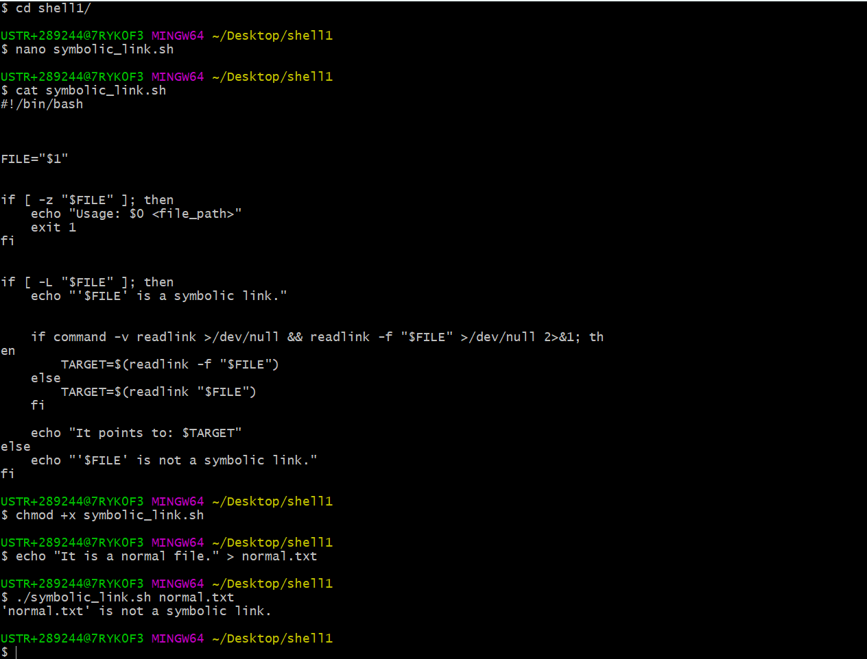

I have created symbolic+link.sh file

Next given permissions  
next tested it